About Us
1. 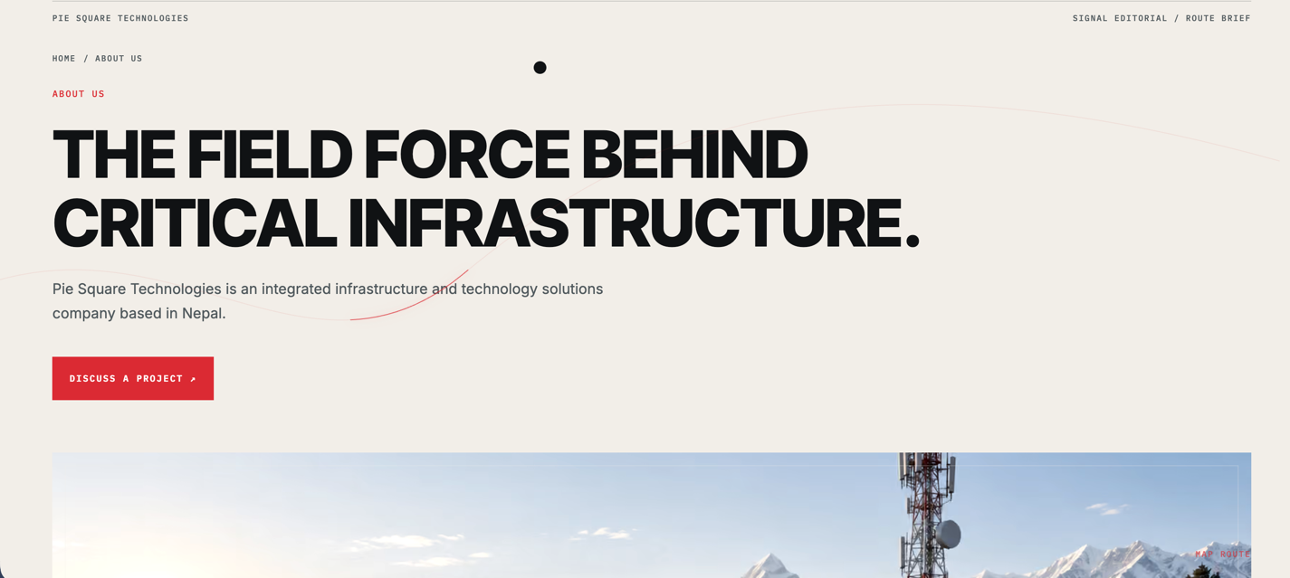
fig1. remarks
- Delet the area in boxes
- Make about us font bigger.
- Make smaller font for arrow marked topic.

2.
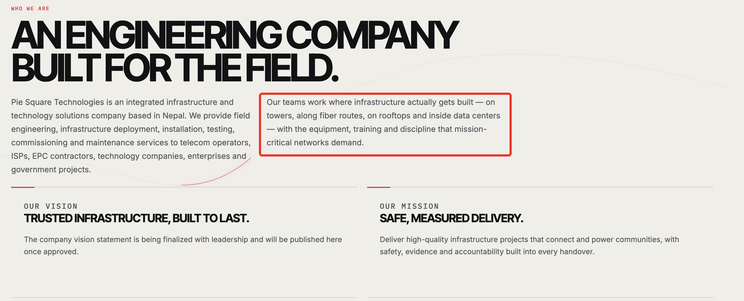
Fig2. remarks
- Make “Who we are” litter bigger than now but smaller than the topic below that.
- topic below that little smaller than now.

2.Replace red box content with –
Our strength lies in bringing multi-disciplinary expertise in Telecom, Fiber Optics, Solar Energy, and IT Infrastructure under one roof, with responsible execution, and EHS compliance enabling clients to manage diverse infrastructure requirements through a single, dependable partner. From field-level execution to project coordination and management, our teams work with a practical, solution-oriented approach to meet demanding project requirements. We continuously focus on operational efficiency, technical accuracy, adaptability, and long-term client relationships, helping build infrastructure that is reliable, scalable, and ready for the future.

3.
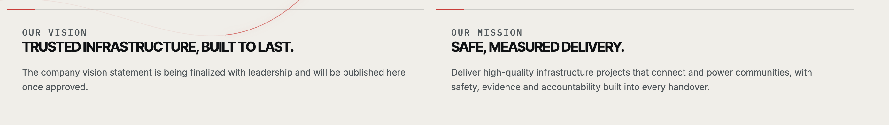
Write in same format:
OUR VISION
Building the infrastructure that connects, powers and enables Nepal.
To create reliable infrastructure that strengthens connectivity, supports sustainable energy, and enables communities and businesses to move forward through technology.

OUR MISSION
Integrated solutions. Reliable delivery.
To deliver integrated infrastructure and technology solutions with quality, safety and accountability, combining engineering expertise, field execution and dependable project delivery across Nepal.

4.
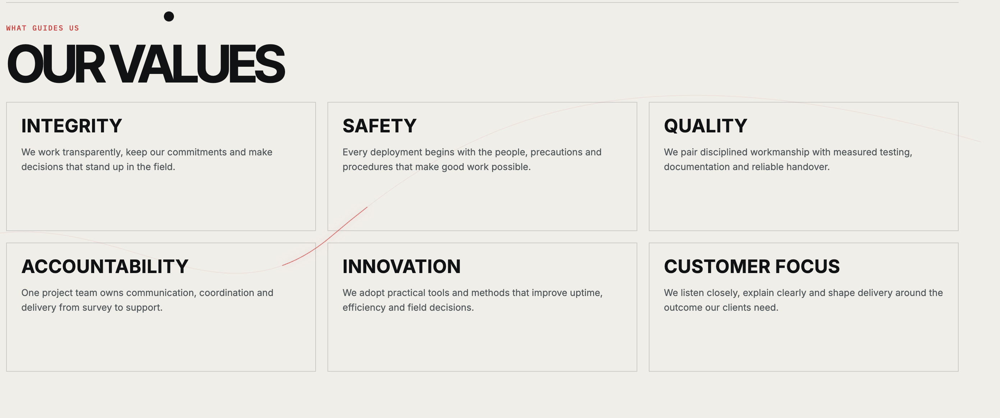
Topics is best no need to change, just minor changes required inside topic.
Integrity-We work transparently, keep our commitments and make decisions that stand up to scrutiny and field realities.
Safety- We promote a proactive safety culture through risk assessment, proper PPE, safe work practices, trained personnel, and continuous EHS awareness—ensuring our people, clients, communities, and the environment are protected.
Quality-We combine disciplined workmanship, measured testing and clear documentation to deliver reliable results.
Accountability-We take ownership of communication, coordination and delivery—from survey and execution to handover and support.
Innovation-We adopt practical technologies, tools and methods that improve efficiency, reliability and field performance.
Customer Focus-We listen closely, communicate clearly and deliver solutions aligned with our clients’ needs and objectives.

5.
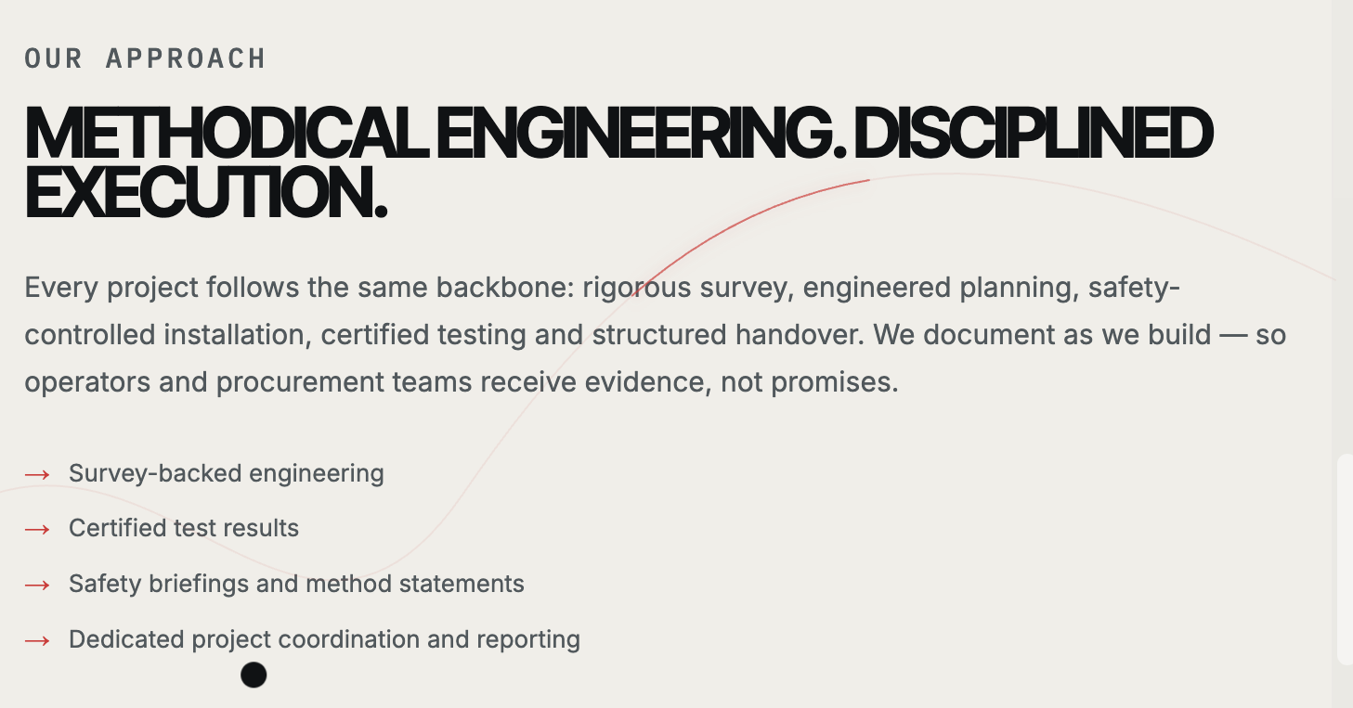
OUR APPROACH
Engineered with Precision. Delivered with Discipline.
Every project follows a structured process—from site survey and planning to safe execution, testing, documentation and handover. We combine engineering discipline with practical field execution to deliver reliable, measurable results.
- Survey-Based Engineering-Field data and site assessments inform practical, build-ready solutions.
- Quality Testing & Documentation-Inspection, testing and documentation provide clear evidence of completed work.
- Safety-Controlled Execution-Method statements, toolbox briefings and site procedures support safe project delivery.
- Dedicated Project Coordination-Clear communication, reporting and coordination keep every project aligned from survey to handover.

6.
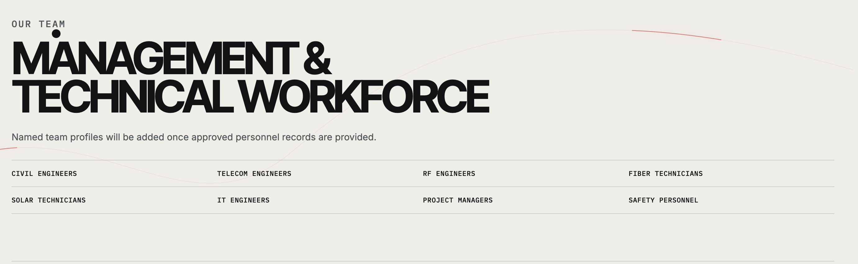
we don’t want to add team profiles or team name.
just write department with designation mentioned below in your formate :
OUR TEAM
Multidisciplinary Expertise. Experinced Delivery Team.
Our multidisciplinary workforce brings together engineering, technical and field expertise to deliver infrastructure projects safely, efficiently and reliably across Nepal.
- Civil Engineering-Civil Engineers · Site Supervisors · Masons & Technicians
- Telecom & RF Engineering- Telecom Engineers · RF Engineers·Technicians
- Fiber & Network Operations- Fiber Technicians .Splicers · O&M Technicians
- Solar & Electrical-Electrical Engineers · Solar Technicians · Electrical Technicians · Site Supervisors
- IT Solutions- Computer Engineers · IT Professionals. IT Technicians
- Project Management & Coordination-Project Managers · Project Coordinators · Planning & Reporting
- Safety & Quality: Safety & Quality Coordinators · Site Supervisors ·

7.
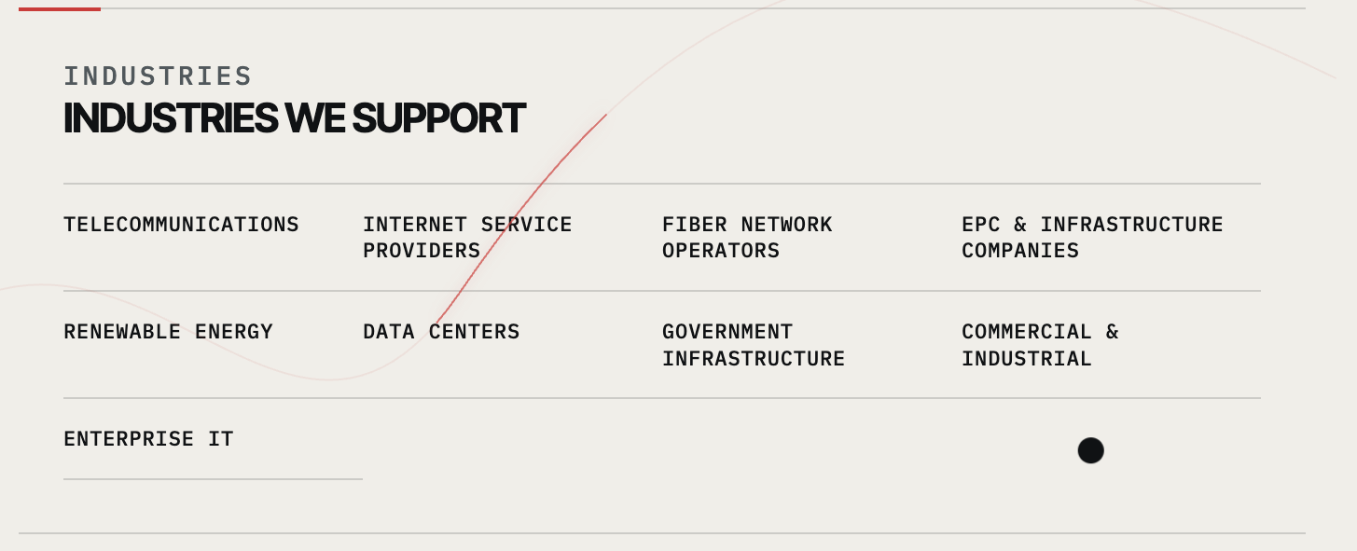
INDUSTRIES WE SUPPORT: Add subheading like this.
TELECOMMUNICATIONS
Tower Works · Equipment Installation · RF · Network Infrastructure · Field Deployment · O&M

INTERNET & FIBER NETWORKS
FTTH · Fiber Deployment · Network Maintenance · Field Operations

EPC & INFRASTRUCTURE
Engineering · Procurement · Construction · Project Execution

RENEWABLE ENERGY
Solar · Electrical Systems · Installation · O&M

IT & DIGITAL INFRASTRUCTURE
Networking · IT Infrastructure · Systems Installation · Technical Support

GOVERNMENT & PUBLIC INFRASTRUCTURE
Infrastructure Deployment · Connectivity · Technology Solutions

COMMERCIAL & INDUSTRIAL
Electrical · Solar · Infrastructure · Technology Solutions

8. Geographical Coverage is OK.

